1. **Steps for creating EBS volume..**
2. **Go to AWS console in AWS interface left bottom side down Elastic Block Store is their ..**
3. **IN That select Volumes..**
4. **Next select the option create volume..**
5. **Add credentials in required section**
6. **Like volumes..enetered 10 GIB….**

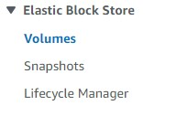

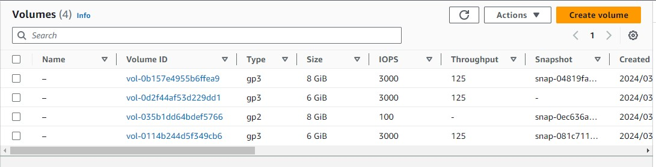

1. **Created successfully volume ….**

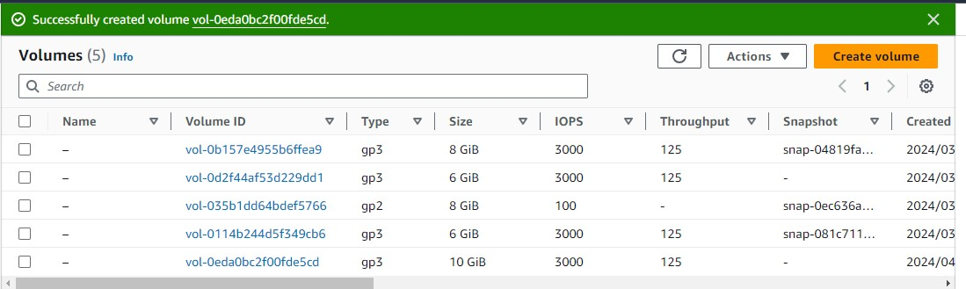

1. **Below image shown that 10 GIB volume….**

